1. Structural Design Pattern.
2. **Application**:
   1. Instead of using a large number of objects, we can reuse existing objects and save memory.
   2. This pattern is useful with mobile app where memory is a big concern.
   3. 
3. **Scenario**:
   1. 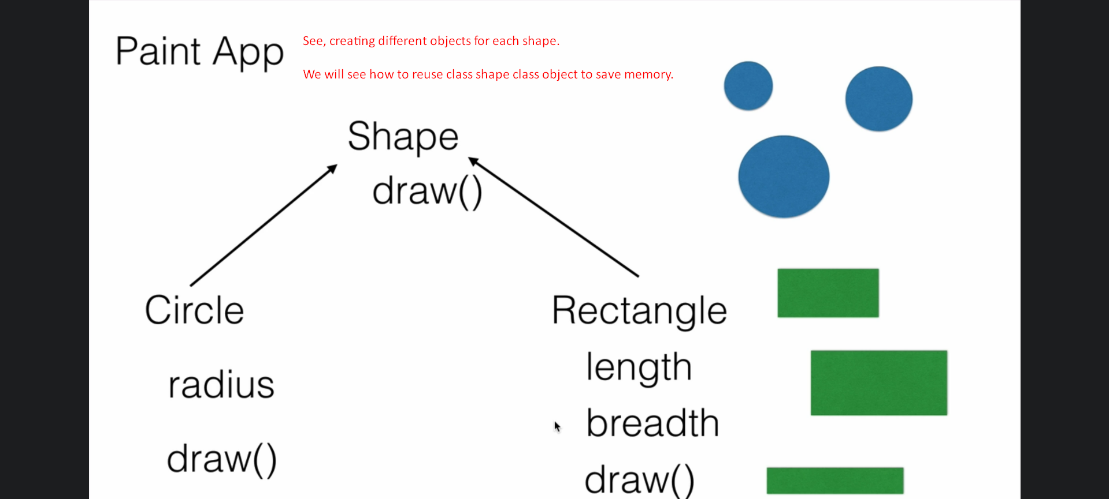
   2. Jatin:
      1. Actually, we will create one object for each shape type.
      2. We will then set data say for Circle object.
      3. We will then draw it.
      4. Now we will set new data on the same Circle object.
      5. We will then draw it.
      6. This way we will be reusing Circle object again and again each time we want to draw circle.